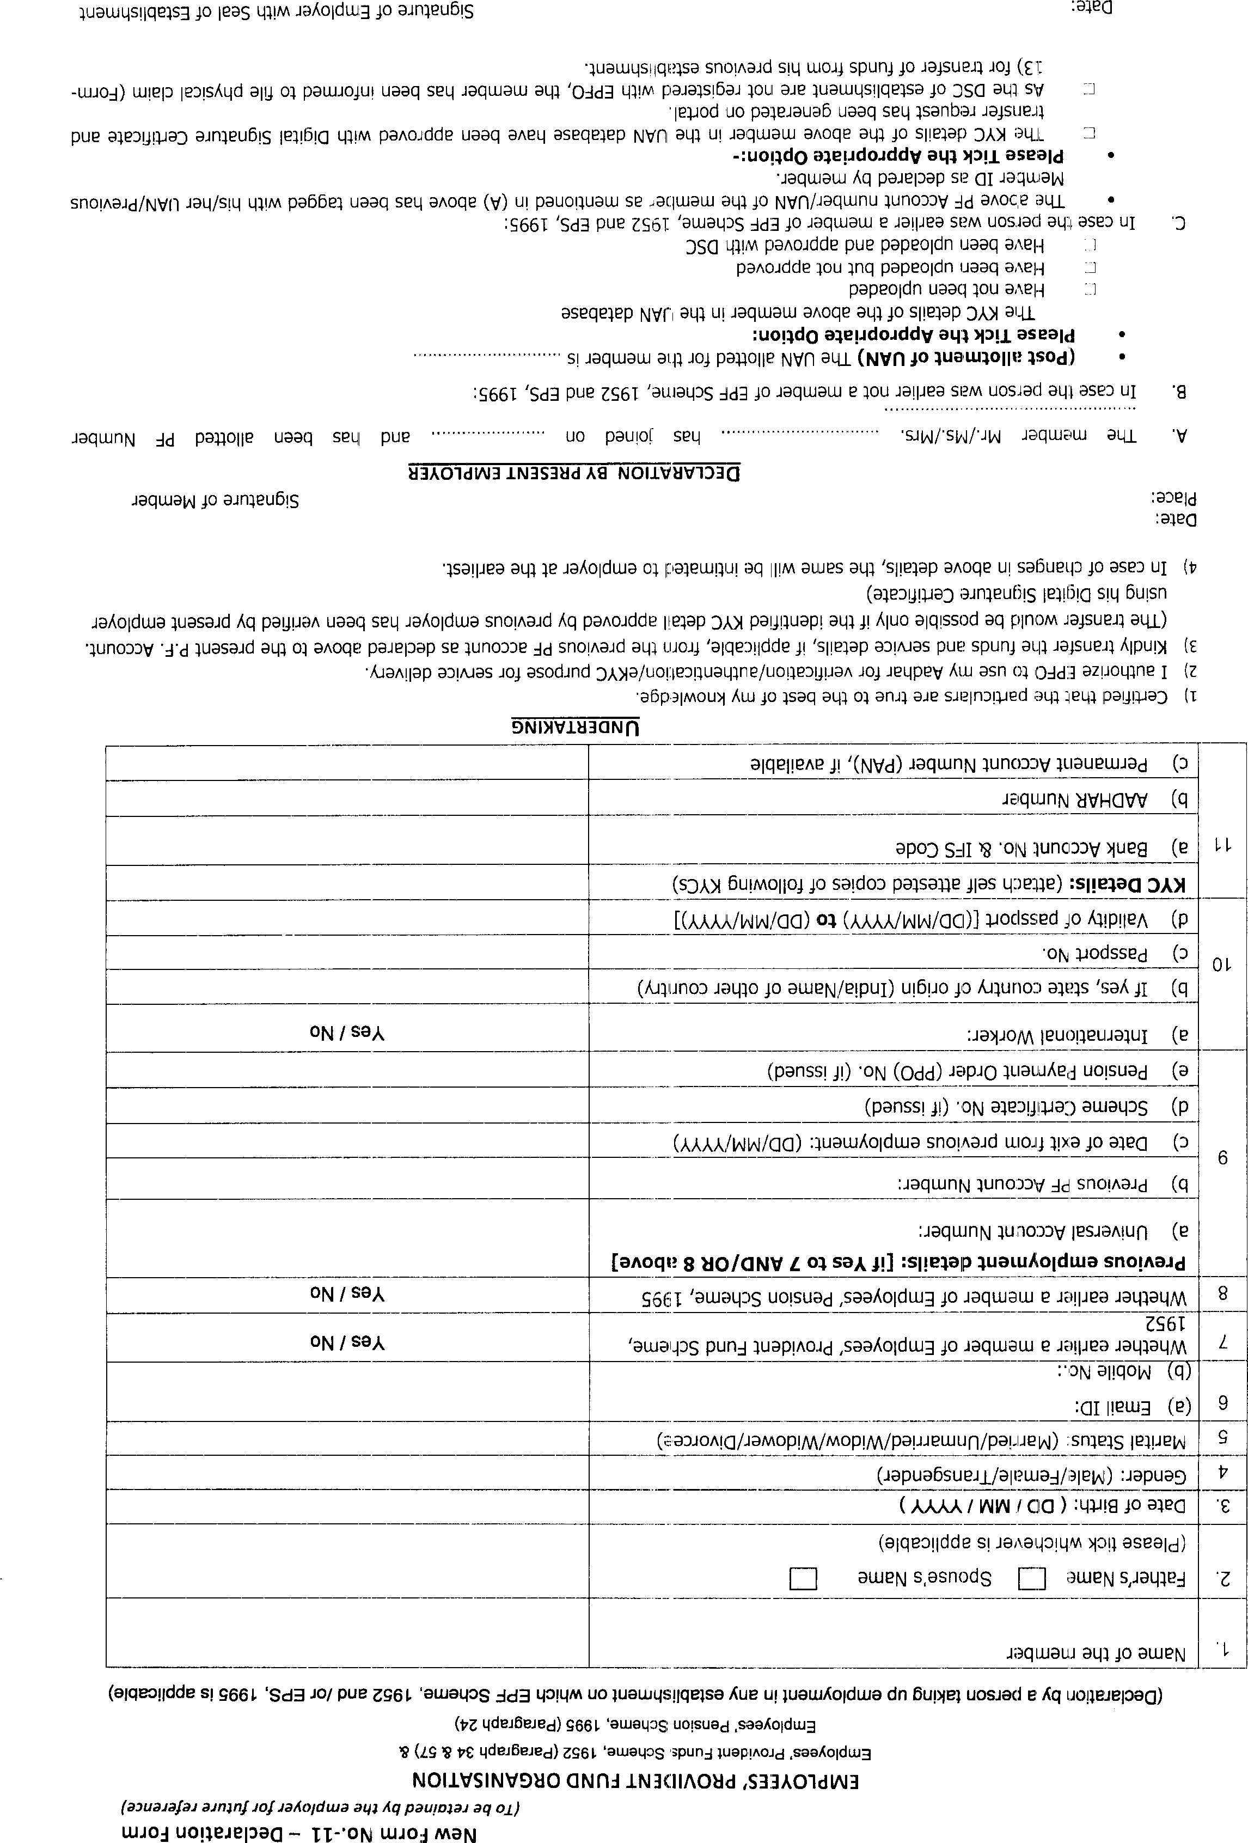
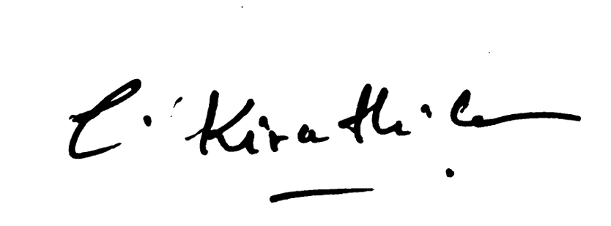
NO
NO
Unmarried
61632200014459
Kiruthi026@gmail.com
7010462109
Female
26/12/2003
CNRB0004381
613884095136

102337489673
Kiruthika C
Chandrasekar A

